
Ain Shams University
Faculty of Engineering
Computer and Artificial Intelligent Engineering Department

Lab Reports 2,3,4,5
Web Development

Student Name: Youssef Lotfy Elsayed Aly Mohamed Youssef
Student ID: 23P0216
Course: CSE343
Submission Date: 11/4/2025

Lab Tasks Repository in GitHub:
https://github.com/yousseflotfy10/Web-Development-Lab-Tasks-.git
Lab Task 2
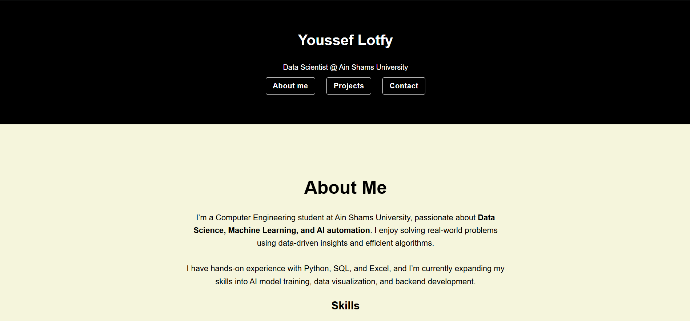
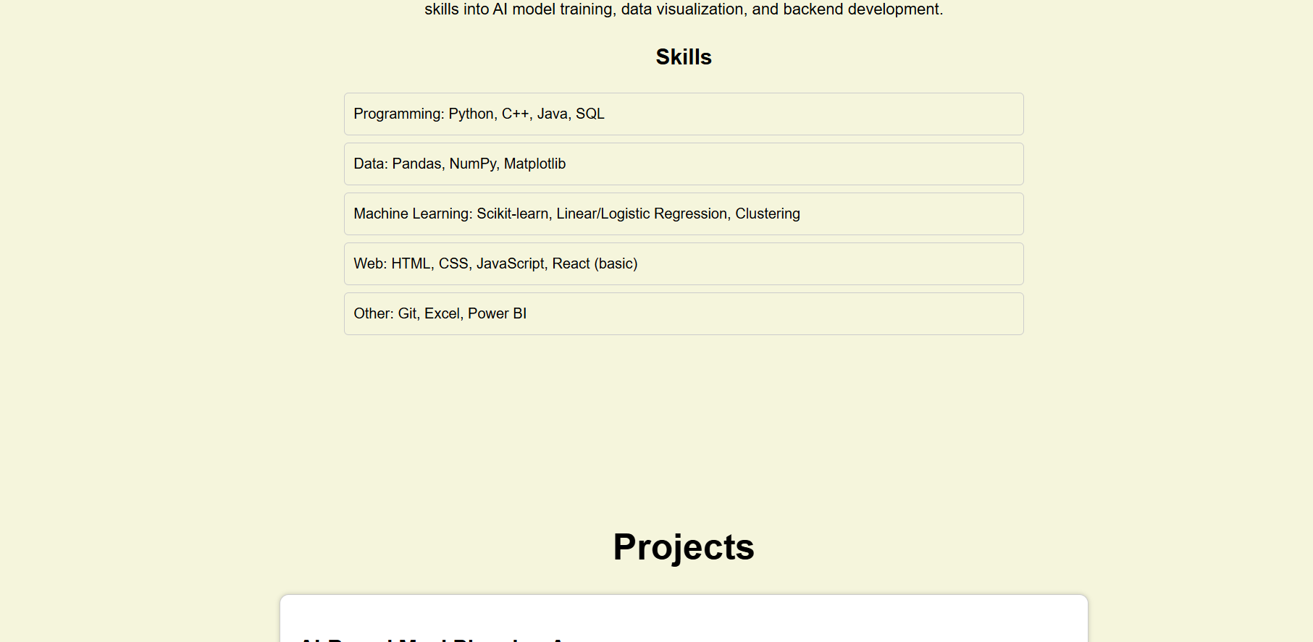
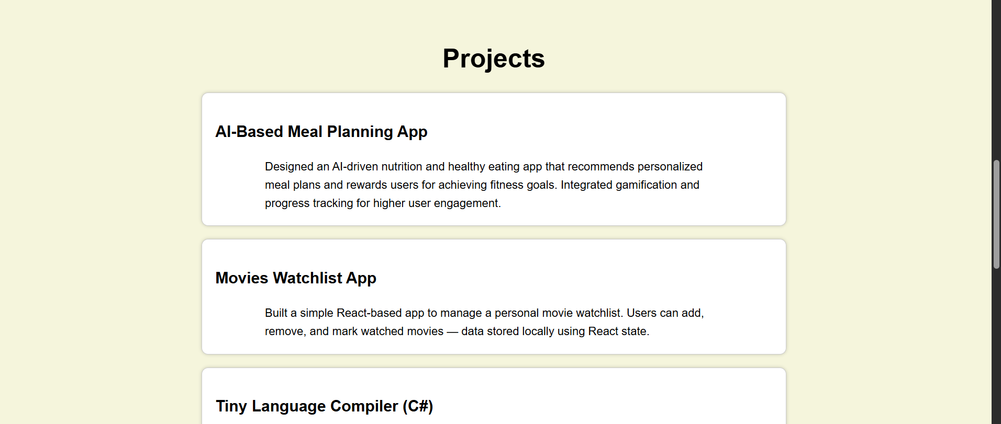
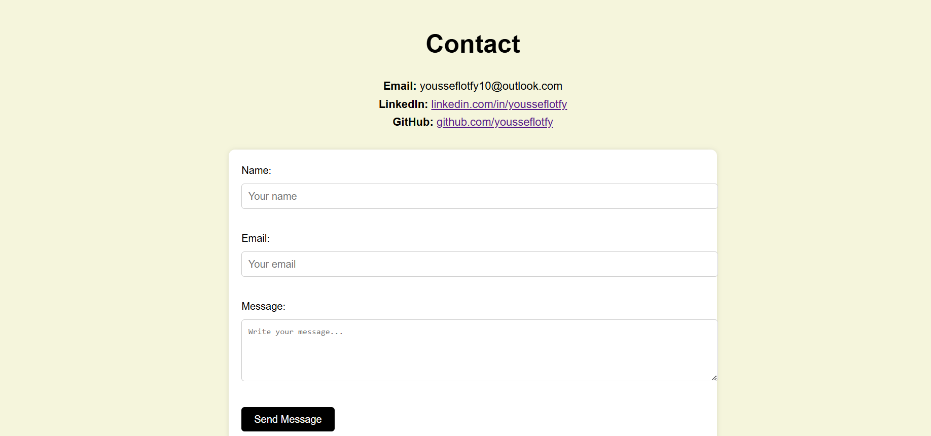

Lab Task 3
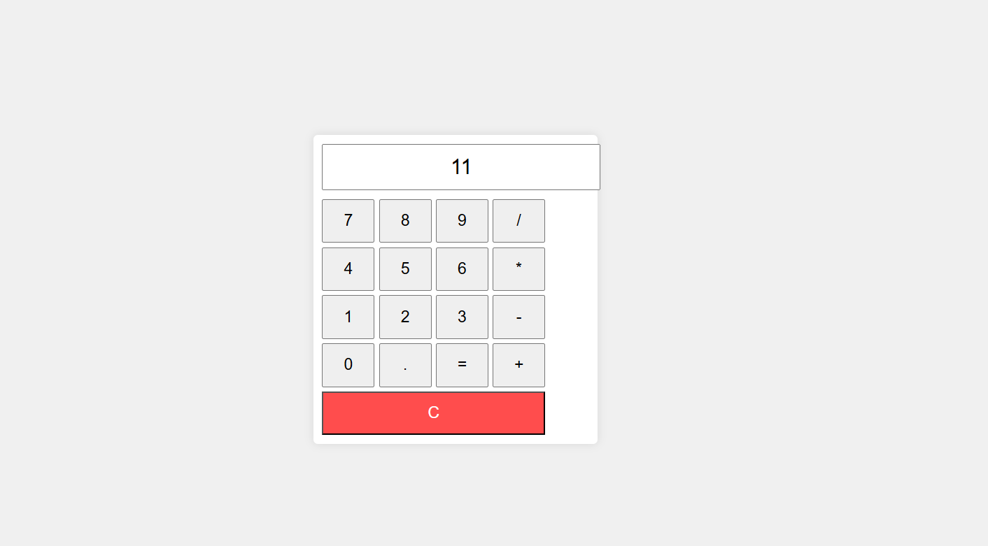
Lab Task 4
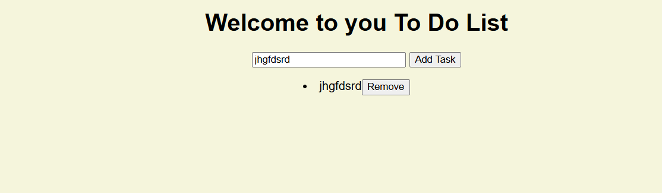

Lab Task 5
